Fraser Triangulation - F ⨹ - Test Project – Final Report

Dave Weaver Dec. 16, 2015

Executive Summary
A.R.Fraser’s original paper in 1972 described how the spatial arrangement of a population of individuals, such as trees, form established triangles and if one was to randomly sample the triangles of that population and measure the areas of those populations, one could therefore calculate the density of those trees per ha. Recently, Peter Ott with FAIB in the spring of2015, expressed interest in revisiting this approach, due to the proposed elevated level of accuracy in this estimate, relative to the current BC plot system of estimating tree populations. Ott stated that the Fraser Methodology is “statistically” more efficient than our current system for it directly measures the spacing between the trees, unlike samples based on plots that can “just miss or just select trees”.
The RPB therefore was motivated to embrace and explore deeper the potential of this Fraser triangulation approach. Subsequently in the summer of 2015, RPB staff designed a project to ultimately test the accuracy and efficiency of the Fraser Triangle Method (F⨹) relative to the current MoF system of sample plots (MoF ⊚) – in the field and in TASS II stem map simulations.
The project outcomes ultimately found the F⨹ method to be less accurate overall than the MoF ⊚ method. In all sample tests (accept the Interior field test, which did not have any original test densities), the MoF ⊚ method was always the most accurate, compared to an original or know population densities. Various intensities of the F⨹ method point centers did not appear to increase the accuracy of the method’s estimates – in fact it decreased the accuracy.
The F⨹ method was found to be just as efficient time wise in the field as the MoF ⊚ method, but less effective, due to its lack of prescriptive ability compared to the flexibility of the current MoF ⊚ method.
The F⨹ method was really only suitable for the estimate of total tree densities – as recommended by Ott. This fact of the approach inherently limits its scope of prescriptive application.
The F⨹ method was also found to be less accurate overall than the MoF ⊚ method in the TASS II model tests and is therefore assumed to be less efficient to be linked to projected modelled yields.
The author recommends that the F⨹ method not be considered any further as an alternative to estimating total tree densities for BC licensee reporting obligations.

Acknowledgements
The author would like to thank Peter Ott with FAIB and Kevin Astridge with RPB for bringing this new concept forward for consideration and assisted in elevating it to the test phase. As well, the author would like to thank Tom Gardner and Richard Grice with Babine BCTS, for their assistance and staff feedback in testing this new method in a one day test prototype session and then operationally testing the F⨹ method in the field (especially thanks to Tom for his advanced Excel formula design for the high math equations).

Introduction
In 2015, Peter Ott (FAIB) - biometrician and Darrell Errico - consultant, put together a paper entitled – Revisiting Fraser’s Triangles as a Basis for Estimating Tree Density, Spatial Distribution and Stocking.
In essence this paper’s goal was to advance the theory behind the early ideas of Fraser and van den Driessche (1972) of using triangles as a basis for forest measurement. They intended to show how a redesigned-unbiased estimate of density can be achieved with this old, but rediscovered approach.
In Fraser’s original paper he described how the spatial arrangement of a population of individuals, such as trees, form established triangles and if one was to randomly sample the triangles of that population and measure the areas of those populations, one could therefore calculate the density of those trees per ha., by using busy, but not too overly complex math. Ott was therefore keen on revisiting this approach, due to the elevated level of proposed accuracy in this estimate, relative to the current BC system of estimating tree populations.
Ott has stated in his paper that the Fraser Methodology, is “statistically” more efficient than BC’s current system for it directly measures the spacing between the trees, unlike samples based on plots that can “just miss or just select trees” and therefore suffer from potential elevated imprecision. In additions this new method would intuitively be faster that the BC sample plot of 3.99 m radius and ultimately cheaper.
Considering these statements and expectations, the RPB was willing to embrace and explore deeper the potential of this Fraser triangulation approach. Therefore for in the summer of 2015, the RPB designed a project to ultimately test the accuracy and efficiency of the Fraser Triangle Method relative to the current MoF system of sample plots – in the field and in TASS II stem map simulations.
In short the intent of the project was to sample operational regenerated openings in the Interior and on the Coast using both the MoF and Fraser methodologies. As well to generate stems maps via TASS II for a completely know total sample population and to physically sample that population to see which survey methodology is the most accurate.
Basically, the procedure for the Fraser Triangle approach is to systematically locate random sampling points throughout the opening to be sampled and then at each sample point accurately measure the distance between the 3 trees that form a triangle that has the point centre located in the middle. The triangle measured must be the “smallest” triangle that captures that point center – so there are rules for this triangle tessellation as well. After the area of each triangle is determined, the mean is calculated and the density derived for that opening.

Project Questions
  - Is the F⨹ more accurate and/or more efficient than the MoF ⊚ (Current MoF 3.99 m plot sample) and how does the SQ ⊚ compare (Stocked Quadrat plot sample – added to the Coastal test site exercise)?
  - Does the F⨹ link more efficiently to projected yields using existing models than the MoF ⊚?

Project Objectives
  - To test the F⨹ Methodology relative to MoF ⊚ in two test environments(and the SQ ⊚ only in the Coastal field test):
- Field situations of planted distributed trees (Coastal and Interior openings); and
- Model generated stem maps of randomly (natural) distributed trees.
  - To collect the following data for all 3 methods:
- Total Trees (TT) per species and average height per species.
  - To compare the Accuracy of F⨹ compared to MoF ⊚ - compared to original known densities and within the model generated known population test;
  - To record for the Field Test the following Efficiency perimeters for all 3 methods:
- Time per Plot/Point to tally;
- Time per Block (for there are different sampling intensities per ha.);
  - To preliminary assess how the data collected via the F⨹ can potentially link more efficiently to projected yields using existing Models;
  - To “prototype” test the F⨹ Methodology first for field functionality and operational suitability (basically could it work and how?).

Initial “Prototype” Field Test
- A total of 5 random plots / point centres were established and all field data was collected (as per 7.0 below),in order to test, experiment and ultimately establish the measurement procedures (steps) for F⨹ and SQ ⊚ relative to the process and equipment used for a MoF ⊚ sample.

6.1 Prototype Test Results (May 8 and June 5, 2015)
- It was determined that F⨹ Option 2 for Point Centre Outside triangle (PCO) is not practical (refer 7.1 below for further details), and not workable due to real GPS accuracy to within +/- 4 m, and sample trees usually as little as 2 m MITD. Therefore Option 1 for PCO is the only practical method, if at all required. The resultant area would just be added to the total of measurements.
- Possible F⨹ Survey product outcomes could be the mapping and colour coding for the PC densities – for example FG - blue; SR – green; NSR – yellow and Target - purple. These colours could be relative to a F⨹ m². The actual calculated values using F⨹ formulas are in red below:
  - F⨹ FG ≥ 7 m² (≥ 700 sph) or ≥ 10 m² (≥ 500 sph) = blue;
  - F⨹ SR ≥ 7 m² (≥ 700 sph) or ≥ 10 m² (≥ 500 sph) = green;
  - F⨹ NSR < 7 m² (< 700 sph) or < 10 m² (< 500 sph) = yellow
  - F⨹ TSS ≥ 4 m² (≥ 1200 sph) or ≥ 5.5 m² (≥ 900 sph) = purple
- Preliminary Recommendation: It was found that the F⨹ method would only be best applied for Single Objective Surveys – like final FG or Regen obligation density surveys only. It was felt that they may be quicker for these type of surveys and more accurate.
The current MoF ⊚ system is far more flexible for multiple survey objectives - like WS, FG, NSR, plantable spots, brushing prescriptions and FH assessment and treatment prescriptions.

6.2 Project Review and Prototype Test Results Review

with Peter Ott and Darrel Errico (Aug. 4, 2015)

- Primary Recommendation: To not use the F⨹ method for WS and therefore subsequently not for FG as well. The reason being as presented by Ott was that even though “WS” triangles do exit in the sampled population of trees, they would not be repeatable. They are basically not a finite population attribute and really are only a population with a “temporary status”, being always relative to a PC location, and considered as “temporary” statistically even for the current MoF ⊚ method. Therefore the application of the F⨹ method is only best applicable for TT estimates, with a tally of “static” attributes – like height, health, competition, etc.
- It was recommended that the closest tree to a PC as a starting point was not necessarily the best approach, but a good starting point. An overall better approach was to attempt to identify the “smallest triangle” around the PC and to test that decision if needed, using the algorithm in Appendix D, to support that determination of the Least Diagonal Neighbour (LDN) triangle.
- The formula for determining the average area of the PC areas (in Appendix B) was initially wrong and needed to be changed to the “harmonic mean” formula.

7.0 Survey Methodology Test

7.1 Field Test Design
- Locate 2 SU’s in total for both Coastal and Interior;
- A minimum of a 10 ha. SU in size is required for each sample and on relatively flat terrain;
- The SU’s should be planted and be within the REGEN window for assessment – about 2 - 3 years;
- Use of all the actual survey parameters is required from the SP for the test – MITD; Species; TSS; MSS;
- Pre-establish uniformly distributed random plots / point centres across both SUs on a grid basis, at the following densities:
- MoF ⊚ 1 plot per ha.(100 meter grid)
Fixed radius plot – 3.99 m;
- F⨹ 2 points per ha. (for this initial data collection, may complete compilation at 1 point per 2 ha., for further refinement of methodology test)
Variable triangular point sample;
- SQ ⊚ 4 plots per ha. (25 meter grid – Coastal test SU only)
Fixed radius plot - – 1.9 m for 900 TSS Coast – 1.6 m for 1200 TSS Interior.

MoF ⊚ Procedure
- At each plot center tally as per the Silviculture Surveys Manual 2015, the TT and WS trees (WS just for curiosity reasons) as per the SP Stocking Standards.

F ⨹ Procedure (revised August 5, 2015)

Point centre inside triangle (PCI - in block)
- At the sample point centre (PC), locate the closest tree to the point centre;
- Locate the other 2 trees that are the Least Diagonal Neighbour (LDN) of that first nearest tree, that locates the point centre within the middle of the smallest triangle (area) produced by these 3 trees. This smallest triangle can be verified 1) by adding up the cumulative 3 distances and using that triangle that is the shortest cumulative distance or 2) by using the algorithm in Appendix D, to support that determination of the LDN triangle.
- Measure the distance between all of these 3 trees (just 3 distances);
- Record the species per tree (max 3 trees).

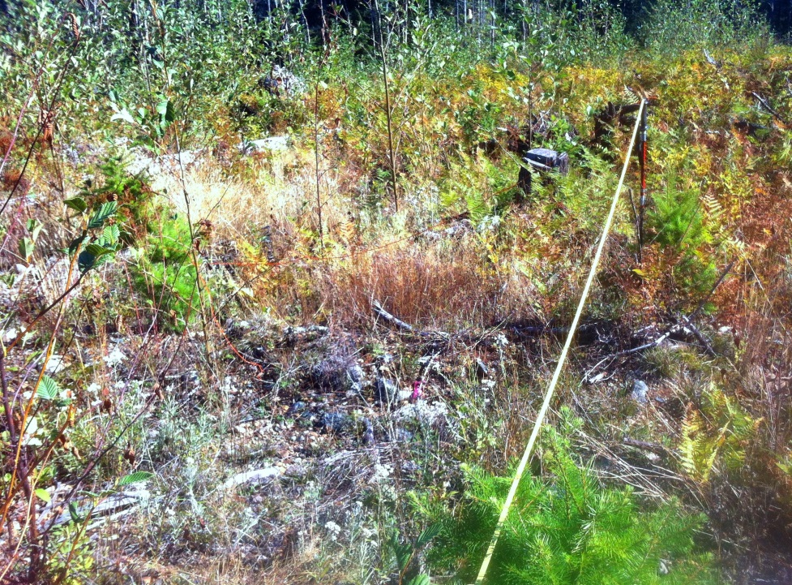
Tree ii
Tree i
Point Center
Tree iii
Photo 1: Actual plot F ⨹ 5b - Coastal Site, showing measurement tape between Trees i and iii.

Point centre outside triangle (PCO - on edge of block - a low probability)
- If at the point centre, it is observed that there are only trees on one side of the PC and the boundary edge of the SU is on the other, then use this procedure – PCO;
- At the point centre, locate the closest 2 LDN trees on one side of the PC;
- Randomly select one of these trees and measure its distance to the boundary edge (at right angles to the boundary) and project that distance beyond the boundary into the non-SU area (mark it with a plot centre marker – like a plot shovel temporarily). This becomes the location of the “ghost” third tree of the triangle.
- Measure the distance between all of these 3 trees (just 3 distances), identifying the 2 projected side measurements;
- Record the species per the first 2 closest trees to the PC.

- SQ ⊚ Procedure (Coastal site only)
- Plots will be established at 4 plots per ha. – roughly every 25 meters on survey lines;
- At each plot centre, tally :
  - TT per plot;
  - Presence or absence of a “WS criteria tree” ( only min. ht., species – no spatial component);
  - Tree species (% for TT).

7.2 Model Test Design and Procedure
- A natural (random) distribution “stem map” was generated by FAIB staff using the TASS II model.
  - The total number of stems generated per ha. on the graphic was 1986 stems per ha.
- This 1 ha. graphic tree distribution was replicated 10 times ( in random rotated adjoining positions in order to mix up the population distribution), to generate a modeled 10 ha. opening – mimicking the same sample size of the field tests.
  - The total number of stems for the 10 ha. opening was now 19,860 stems.
- Once mapped completely, then 10 plot/point centers were located randomly on a 100 m grid, and resultantly locating one center in each ha. of the 10 ha. opening. This was repeated 3 times, to generate 3 completely random placed plot/point centers in each ha. of the 10 ha. opening and therefore generating 3 sets of modeled plot data.

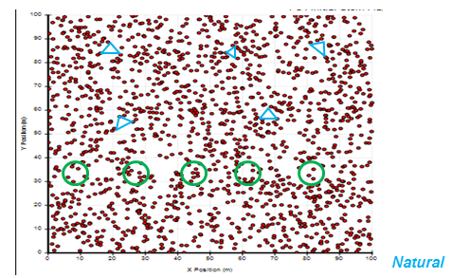
Figure 1: Actual copy of TASS II generated 1 ha. Stem Map, showing example F⨹ blue plots and MoF⊚ green 3.99 m plots - for demonstration only.

- At each point center (PC):
  - The 3 sides of each LDN triangle (smallest triangle enclosing the PC) were measured; and
  - The total stems per 3.99 m scaled plot boundary, were tallied.

8.0 Test Results

8.1 Field Test
1) Coastal Prototype Test – May 8, 2015: Thames Creek BCTS, 5.0 ha. NAR.

 | MoF ⊚ |  | F ⨹ |  | SQ ⊚  (% stocked) | Opening Data  (Org)
Total Plots / PC | 5 |  | 4 |  | 11
Total Trees /Ha | (include Dr) | % Org | (include Dr) | % Org | (include Dr) | 1480 (Pl 2012)
1 sample /ha. | 1600 | 11.3 % | 1818 | 26.4 % |  | 1438 (REGEN 2012)
2.5 samples /ha |  |  |  |  | 1993 (100%)
WS Trees /Ha | TWS (WSm) |  |  | % MoF
1 sample /ha. | 1080 (820) |  | 1617 | 49.7 %

1) Coastal Site – Sept. 8, 2015: Thames Creek BCTS, 10.2 ha. NAR.

 | MoF ⊚ |  | F ⨹ |  | SQ ⊚  (% stocked) | Opening Data  (Org)
Total Plots / PC | 10 |  | 20 |  | 40
Total Trees /Ha | (no Dr) | % Org | (no Dr) | % Org | (no Dr)
1 sample /ha. | 1300 | 9.6 % | 2716 | 88.9 % |  | 1438 (REGEN 2012)
2 samples / ha. |  |  | 2171 | 51 % |  | 1480 (Pl 2012)
1 sample /2 ha. |  |  | 1577 (1st alt 5)  3855 (2nd alt 5) | 10 %  168%
4 samples /ha |  |  |  |  | 1644(97.5%)
WS Trees /Ha | TWS (WSm) |  |  | % MoF
1 sample /ha. | 1000 (810) |  | 1437 | 43.7 %
2 samples / ha. | N/A |  | 1413 | 41.3 %
1 sample /2 ha. | N/A |  | 1287 (1st alt 5)  1588 (2nd alt 5) | 28.7%  58.8 %

2) Interior Site – Oct 22, 2015: Henkel Creek BCTS, 11.5 NAR

 | MoF ⊚ |  | F ⨹ |  | SQ ⊚ | Opening Data
Total Plots / PC | 11 |  | 11 |  | N/A
Total Trees /Ha | (no At) |  | (no At) | % MoF
1 sample /ha. | 2727 |  | 2730 | 0.1 % |  | (no Label w Nat)
2 samples / ha. |  |  | N/A |  |  | 1852 (Pl 2015)
1 sample /2 ha. |  |  | 2860 (1st alt 5)  2830 (2nd alt 5) | 5.9 %  3.7 %
WS Trees /Ha | TWS (WSm) |  |  | % MoF
1 sample /ha. | 1327 (1182) |  | 1536 | 15.7 %
2 samples / ha. | N/A
1 sample /2 ha. | N/A |  | 1462 (1st alt 5)  1601 (2nd alt 5) | 10.2 %  20.6 %

8.2 Model Test
1) FIRST - TASS Generated Stem Map (natural) – Sept. 26, 2015: Total simulated opening area 10.0 ha. NAR.

 | MoF ⊚ |  | F ⨹ |  | SQ ⊚ | Opening Data  (Org)
Total Plots / PC | 10 |  | 10 |  | N/A
Total Trees /Ha |  | % Org |  | % Org
1 sample /ha. | 2280 | 14.8 % | 2403 | 21.0 % |  | 1986 (Complete Pop Count)
1 sample /2 ha. | N/A |  | 1722 (1st alt 5)  3085 (2nd alt 5) | 13.3 %  55.3 %

2) SECOND - TASS Generated Stem Map (natural)– Sept. 26, 2015: Total simulated opening area 10.0 ha. NAR.

 | MoF ⊚ |  | F ⨹ |  | SQ ⊚ | Opening Data  (Org)
Total Plots / PC | 10 |  | 10 |  | N/A
Total Trees /Ha |  | % Org |  | % Org
1 sample /ha. | 1900 | 4.3 % | 2394 | 20.5 % |  | 1986 (Complete Pop Count)
1 sample /2 ha. | N/A |  | 2521 (1st alt 5)  2267 (2nd alt 5) | 26.9 %  14.2 %

3) THIRD - TASS Generated Stem Map (natural) – Sept. 26, 2015: Total simulated opening area 10.0 ha. NAR.

 | MoF ⊚ |  | F ⨹ |  | SQ ⊚ | Opening Data  (Org)
Total Plots / PC | 10 |  | 10 |  | N/A
Total Trees /Ha |  | % Org |  | % Org
1 sample /ha. | 1840 | 7.4 % | 1584 | 20.2 % |  | 1986 (Complete Pop Count)
1 sample /2 ha. | N/A |  | 1450 (1st alt 5)  1718 (2nd alt 5) | 27.0 %  13.5 %

Note: Accuracy of the estimates of the densities are based on the sampled estimates’ relative % stems that estimate are within, compared to the original population density (if an original density [Org] is known – like a past survey or totally counted stems – as in the case of the TASS Stem Map).
Precision Standards for survey data quality of legal silviculture milestones are defined within the FPPR document RESULTS Information Submissions Specifications 2015 (RISS) – page 53. Here the precision standards are listed the same way as these estimates of densities have been calculated in this methodology test project. Therefore, accuracy for reporting must be within +/- 20 % stems/ha. for Total Trees (TT) and within +/- 10% stems/ha. for WS.

9.0 Conclusions
Project Questions:
- Is the F⨹ more accurate and/or more efficient than MoF ⊚ (Current MoF 3.99 m plot sample) and how does the SQ ⊚ compare (Stocked Quadrat plot sample)?
The F⨹ method was found to be less accurate overall than the MoF ⊚ method.
- In all sample tests (accept the Interior field test, which did not have any original test densities), the MoF ⊚ method was always the most accurate, compared to an original or know population density:
MoF ⊚ 11.3% 9.6% 14.8% 4.3% 7.4% - consistently < 20% - MoF Prec. Std.
F⨹ 26.4% 88.9% 21.0% 20.5% 20.2% - consistently ≥ 20% - Above Prec. Std.
- Various intensities of F⨹ method point centers did not appear to increase the accuracy of the method’s estimates. In fact, wide variations of estimates resulted from various intensities and depended on the point centers selected relative to lower sample sizes:
F⨹ 2 PC/ha. to 1PC/2ha.ranged in accuracy from original at 10% to 168% of original.
- The one Interior F⨹ method estimate of the TT was very close to the MoF ⊚ method estimate – within 0.1%. But it was unknown what the original population was and therefore an objective assessment was not possible. It is assumed that these estimates are so close because the original population was just established 3 months prior at a high planting density and a very uniform distribution resulted. Therefore, it is concluded that any estimate method used to sample this population would be very similar, due to the high degree of uniformity. This exposes the applicableness of the F⨹ method to be best suited in extremely uniform populations – like uniform Agro/forestry plantations – where this method is presently used in the southern hemisphere.
The SQ ⊚ was found to be inaccurate in estimating the TT count compared to the MoF ⊚ and original data.
- The SQ ⊚ method was only tested with the other 2 methods in the Coastal Prototype and Coastal full assessment, however in both cases it’s estimate were always higher than the others – ranging from 25% to 26% > MoF ⊚; and 14% to 39% > the original density.
The F⨹ method was found to be just as efficient time wise in the filed as the MoF ⊚ method, but less effective, due to its lack of prescriptive ability compared to the flexibility of the current MoF ⊚ method.
- It was found in all test methodologies, that if one is only collecting the Total Tree Count – as determined by the recommendations by Ott and Errico – then the F⨹ method could take just as long at a point center as the MoF ⊚ method. This was especially true if there was an issue with deciding on the smallest triangle and additional double triangle measurements had to be taken (this issue probably only happened about 20% of the time – but it did happen in the field and in the model simulation test exercises as well).
- However the inflexibility of the F⨹ method to collect any additional stand characteristics or prescriptive data (i.e. WS, Plantable Spots or bush species densities), limited the apparent application of this methodology in operations, - compared to the current MoF ⊚ method.
- The SQ ⊚ method was definitely the fastest method per plot, but overall probably took the same amount of time to complete – due to 4 times more plots required to be established and the same area of the opening was having to be walked regardless of methodology.

- Does F⨹ link more efficiently to projected yields using existing models than the MoF ⊚ ?
The F⨹ method was found to be less accurate overall than the MoF ⊚ method in the TASS II model test and is therefore assumed to be less efficient to be linked to projected yields.
- In the TASS II tests with a known population sample, the MoF ⊚ method was shown to be 5 to 15% more accurate than the F⨹ method. This is probably due to the “Natural/Random” distribution specifically selected to test these approaches. It is speculated that the F⨹ method would perform just as well as the MoF ⊚ method in a “Planted” distribution (this was evident within the uniform Interior test). For this reason, the “natural” distribution was selected, to truly test the approaches for normal field stand composition situations for modeling forecasted yields.

10.0 Recommendations
- That the F⨹ method not be considered any further as an alternative to estimating total tree densities for BC licensee reporting obligations and not for yield forecasting either.
  - Due to the inherent lack of flexibility in F⨹ method, it has been determined that this approach would not be recommended as a functional field assessment tool. In fact, since only uniform total tree counts are really the only possible application of this approach, its use would further be diminished since the future appears to moving quickly to complete opening imagery census - that would be able to tally completely all of the stems in an opening population – without any sampling at all. This technology is currently available and is anticipated to be operational within 2 or 3 years. Therefore, this forecast further supports not spending anymore effort in assessing the use of the F⨹ method.
- That the SQ ⊚ method not be perused as an alternative yet to the MoF system.
  - It appears in the tests performed above, that its application would be very limited as well, considering the majority of current licensees stocking standards. The SQ ⊚ method consistently over estimated total trees and was unable to assess stocking in a quantitative way – only % stocking - which was not convertible to WS or FG per ha. standards. As well, this method being a smaller and quicker plot was negated considering the substantial more plots needed to be established – effectively equalling the current MoF process time on the block in the field.

Appendix A – Notes from Fraser 1977
- Least Diagonal Neighbour (LDN) concept
- Given a random sampling point on the ground, nearby pairs of LDN's forming a triangle embracing the point are readily found and the area of the triangle may be determined from simple measures of its sides. Since such a triangle is known to be a member of a unique set of such triangles covering a given forested area, the probability of drawing the triangle equals its area divided by the area of the forest.
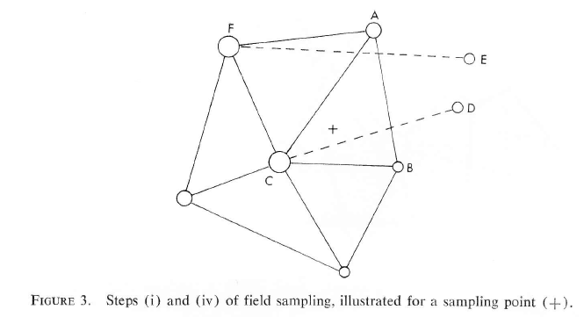
- A simple random sample of n coordinate points is drawn. The points are visited
in any convenient order and at each:
(i) Establish the LDN triangle in which the sample point falls, see Figure 3.
This requires a choice, based on experience, of three trees such as A, B, C, which
form a triangle embracing the sample point and with no other trees on the sides or
within the triangle. A check is then made that no joins occur among nearby trees of
the kinds CD or EF which are shorter than any intersected side of the selected triangle.
Otherwise amend choices of A, B, C.
(ii) Take measures

Appendix B – Formulas from Ott, 2015

Density Estimate (from Point Centre [PC] Data)

Step 1 – Area for each PC triangle (Herons Formula – Appendix C)
________________
Area (m2) of each PC Triangle ⨹ = a_{i} = √s(s-i) (s-ii) (s-iii)

Where:
s = i+ii+iii and i, ii , iii are the 3 measured sides (meters) of the PC triangle
2 (inside or outside)

Step 2 – Average the PC Areas (m2) – harmonic mean formula

ā = K___ / 10,000 m²
𝚺 _1_
a_{i}

Where:
K = the number of PCs
Divided by 10,000 m² to convert to ha.

Step 3 – Determine the Density ($\hat{D}$) for the Opening (Stems per Ha.)

$\hat{D}=\frac{1}{2ā}-\frac{1}{A}$

Where:
A = is the Net Area to Reforest (NAR) in Ha.

Appendix C – Herons Formula

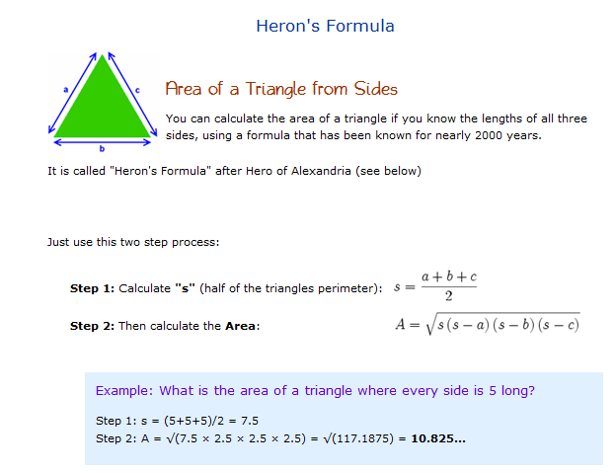

Appendix D – LDN triangle “Brute Force” Algorithm (Ott, 2015)

A brute force algorithm to determine the LDN triangle enclosing a random point
Start with a preliminary triangle enclosing the random point (+) with vertex trees (arbitrarily labelled) A, B and C. Denote this as ΔABC. There must be no other trees within it. A good choice is the smallest triangle or the one with the minimum total side-length triangle that encloses the random point. Let A’ be the closest tree opposite to A (outside of ΔABC) with AA’ intersecting BC. If |AA’| < |BC|, then ΔABC is clearly a poor choice and use instead ΔAA’B or ΔAA’C depending on where the point lies, and re-label the new enclosing triangle as ΔABC. When re-labelling, it is important to retain the label for A and alter only the labels for B and/or C.
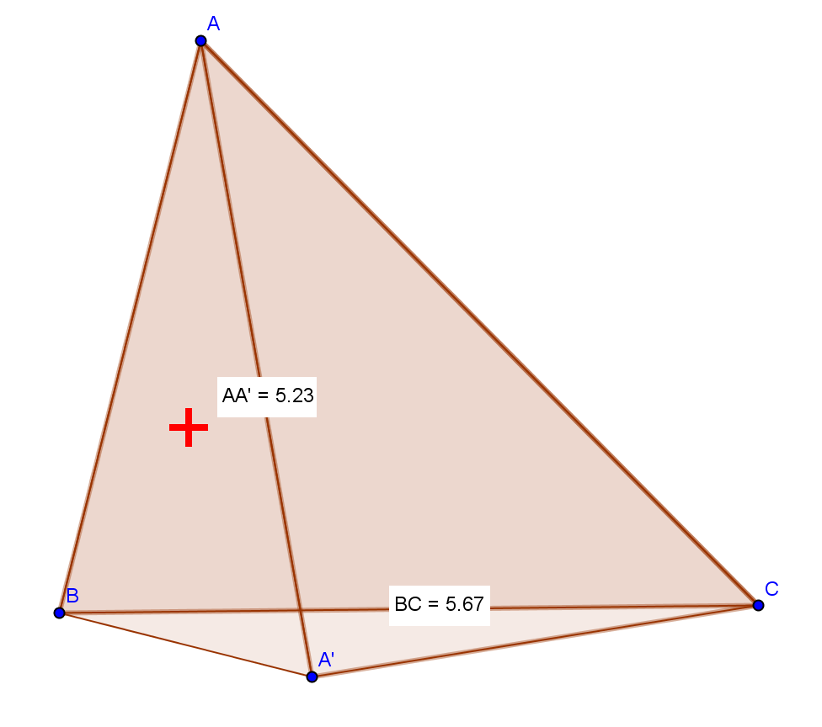
The algorithm officially begins from this state, with tree A’ having already been tested. [This saves having to consider all 27 possibilities and focus just on 9.]
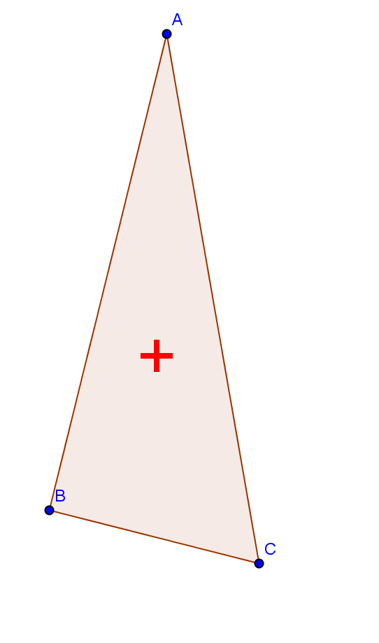
Next, let B’ be the closest tree opposite to B (outside of ΔABC), with BB’ intersecting AC.
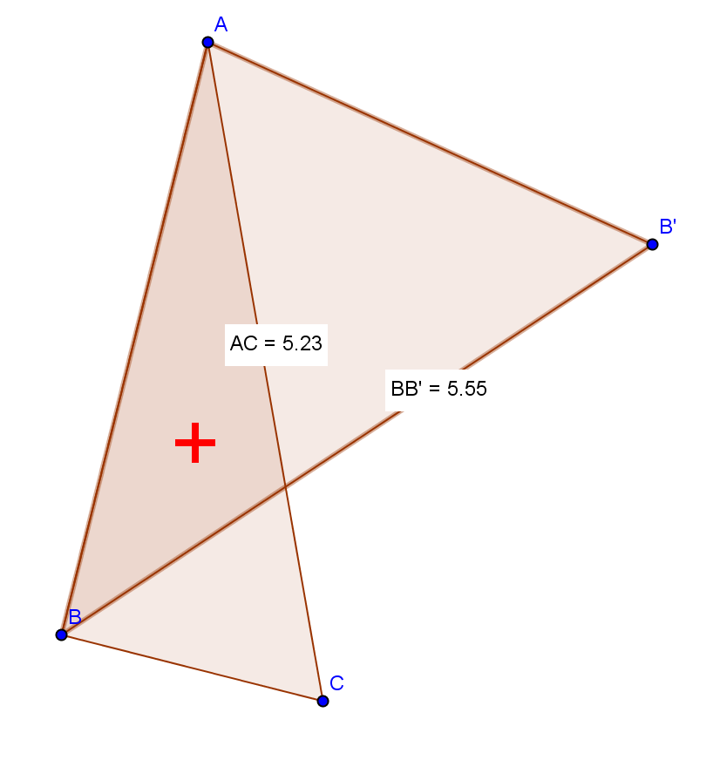
If |BB’| ≥ |AC| then then AC is guaranteed to be one side of the LDN triangle, and only one final test remains. It involves tree C’, the closest tree opposite tree C (intersecting AB) outside of ΔABC:

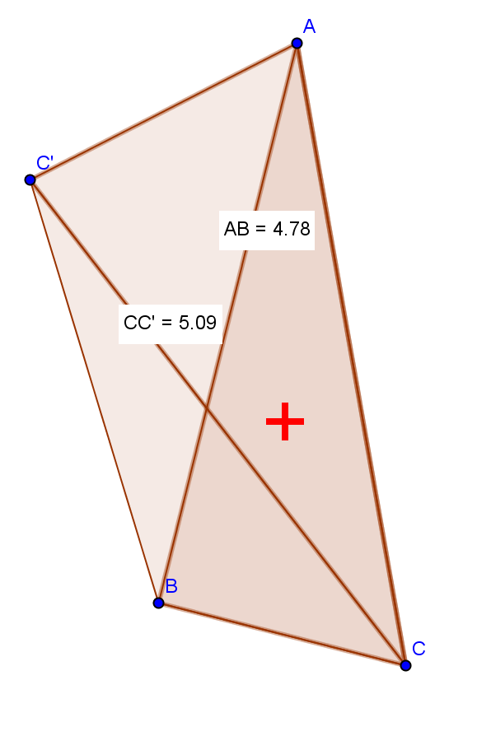
If |CC’| ≥ |AB| then ΔABC is the enclosing LDN triangle. Q.E.D.
Below is the full decision tree, with all possibilities shown, starting from the stage immediately after testing tree A’. It looks messy but with a half-decent preliminary starting triangle, few adjustments will be needed.

Notes:
Tree B_{A}’ is the closest tree opposite B’ intersecting AB. Note that it may not be the same as tree C’ (opposite to C intersecting AB).
Tree B_{C}’ is the closest tree opposite B’ intersecting BC. It may not be the same as tree A’ (opposite to A intersecting BC).

